Ex-no: 10 M. Rohith
06-05-2024 3122 21 5001 085

UCS 2611 INTERNET PROGRAMMING LABORATORY

10. THREE TIER ARCHITECTURE APPLICATION

Hierarchy:

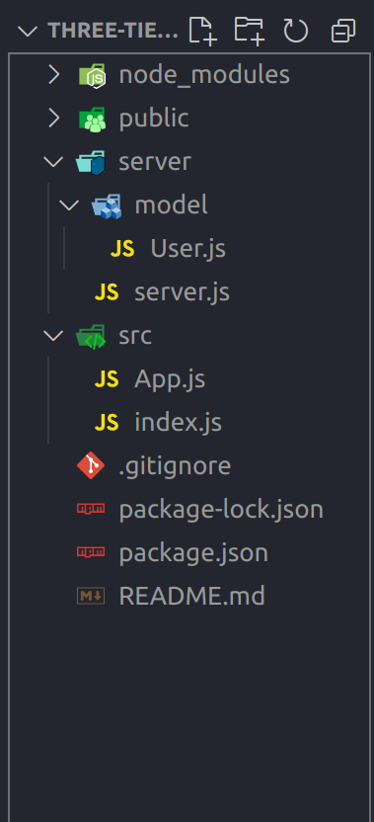

Program code:

App.js (client code)

import {useEffect, useState} from 'react';
import axios from 'axios';
function App() {
const [users, setUsers] = useState([]);
console.log(users)
useEffect(() => {
axios.get('http://localhost:3001/getUsers')
.then((users)=>{
setUsers(users.data)
}).catch(err=>{
console.log(err)
})
},[]);
return (
<div>
<h1>MVC architecture as client and server model</h1>
{users.map(user => (
<div key={user._id}>
<h1>{user.name}</h1>
<h1>{user.rno}</h1>
</div>
))}
</div>
);
}
export default App;

User.js (module code)

const mongoose=require('mongoose');

const userSchema=new mongoose.Schema({
name:{
type:String,
required:true
},
rno:{
type:Number,
required:true
}

})

const userModel=mongoose.model('users',userSchema);
module.exports=userModel;

server.js (server code)

const express = require("express");
const mongoose = require("mongoose");
const cors = require("cors");
const UserModel = require("./model/User");

const app = express();
app.use(cors());
app.use(express.json());

mongoose.connect("mongodb://0.0.0.0:27017/student");

app.get("/getUsers", (req, res) => {
UserModel.find({}).then(function(users){
res.json(users);
}).catch(function(err){
res.json(err)
})
});

app.listen(3001, () => {
console.log("Server is running on port 3001");
})

index.js

import React from 'react';
import ReactDOM from 'react-dom/client';
import App from './App';

const root = ReactDOM.createRoot(document.getElementById('root'));
root.render(
<React.StrictMode>
<App />
</React.StrictMode>
);

Output:

